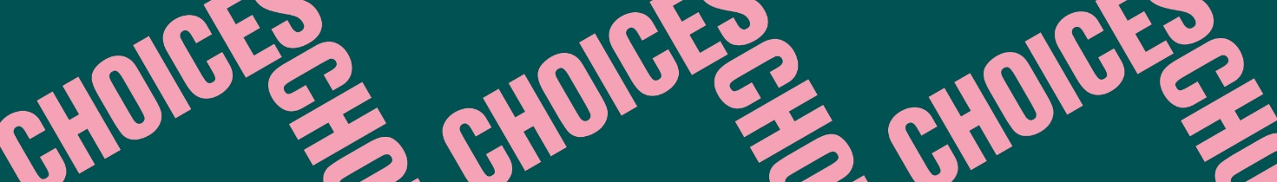

Choices and Consequences
Hard Choices
Vocabulary 1: Literary terms
Place the following literary terms under the correct heading. Some terms can be placed under more than one heading.
act – audience – author – character – chapter – climax – composition – flashback – interpretation – message – metaphor – mood – narrator – playwright – plot – plot twist – poet – point of view – repetition – rhyme – rhythm – scene – setting – speaker – stanza – symbol – theme – tone – turning point
Short story/Novel | Poetry | Play

