Choices and Consequences
New Beginnings
Analysis 1: Character analysis of Shona and her father
- How do Shona and her father feel about the current situation? Discuss which of the following adjectives characterize Shona and her father.
afraid – aggressive – angry – bitter – concerned – cruel – depressed – disappointed – embarrassed – emotional – enthusiastic – excited – frustrated – guilty – happy – hopeful – humble – irritated – jealous – loyal – miserable – nervous – optimistic – patient – pessimistic – positive – proud – sad – scared – selfish – upset – troubled – worried
Focus on similarities and differences. Place the adjectives in the diagram below. Place the adjectives that characterize both Shona and her father in the area in the middle.

Shona Shona’s father

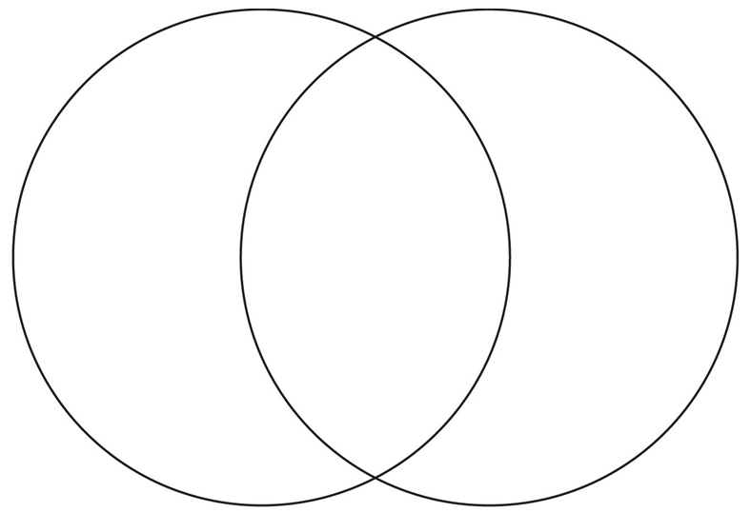

- Describe Shona’s father from Shona’s point of view.
- Describe Shona from her father’s point of view when Shona tells him about moving to New Zealand.

