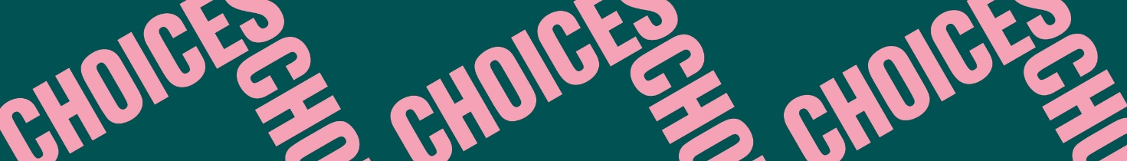

Twisted Stories
Button, Button
Vocabulary: Repetition of literary terms
Fill in the blanks with the correct literary term to make a definition of each of these literary terms: character – climax – narrator – plot – point of view – setting – symbol – theme
- The __________ is the time and place a story takes place.
- The __________ is the one who tells the story.
- The __________ is the sequence of events in a story.
- The __________ of a plot is the central turning point of the story.
- The __________ is the perspective from which a story is told.
- The __________ is the central idea, topic, or point of a literary work.
- A __________ is a thing that stands for something else.
- A __________ is a person in, for instance, a short story.
- A __________ is the unexpected development in a story.

