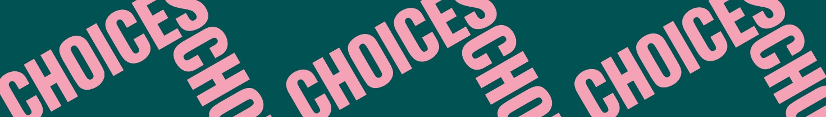

Twisted Stories
Yosemite
Vocabulary: Microfiction
Read the following text about microfiction. Fill in the blanks with these words:
300 words – characters – details – end – fiction – flash fiction – meaning – plot – short – twist – word – words

- Microfiction is a literary genre of ________ that is defined as a very short story.
Microfiction is also called ________.
- There are no strict rules about the word count of microfiction stories, but they are typically
shorter than ________ and some stories might even be as short as a few sentences or a
few ________.
- The common characteristics of microfiction are:
Length: Microfiction is very ________. An entire story is often told in one paragraph.
Plot: Even though the story is very short, the story will have a ________ with a beginning, a middle, and an ________.
Plot twist: Microfiction stories often end with some sort of surprise giving the text at
________ at the end. The purpose of the plot twist is to make the reader think about the
deeper ________ of the story.
- Microfiction typically uses one point of view and only a few ________.
- Since microfiction stories are very short, every single ________ used has a purpose and
- microfiction should be read carefully with attention to all ________.

