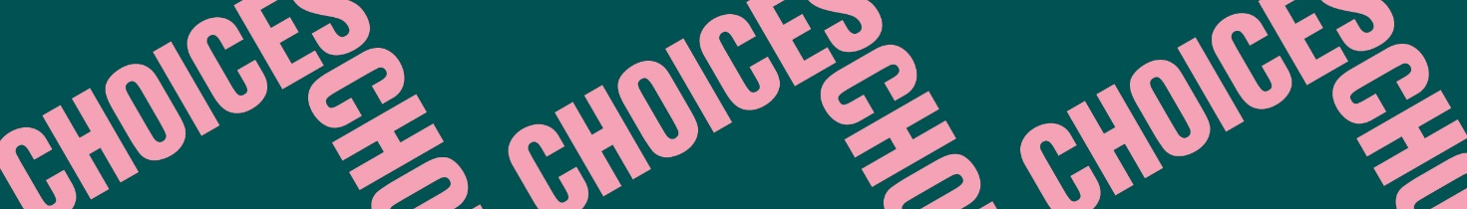

Twisted Stories
Pre-reading
Pre-reading 4: What is a plot twist?
Read the following text about plot twists. Fill in the blanks with these words:
change – end – first person – hints – literary technique – narrator – plot – reader – trick – trusted

- A plot twist is a ________ used to radically change the ________ in a work of fiction.
- A plot twist usually happens near the ________ of a story. It is used to ________ the reader’s understanding of a story.
- A plot twist is often foreshadowed, which means that ________ or clues are used to suggest what will happen later in a story.
- Another way to create a plot twist is to keep important information from the ________ or use misleading information to ________ the reader.
- In stories with plot twists, it is very common to use an unreliable ________, which means that the narrator cannot be ________. An unreliable narrator is typically a ________ narrator.

