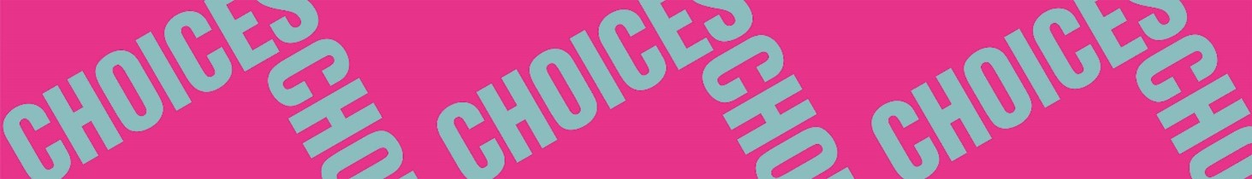

Twisted Stories
Pre-reading
Pre-reading 1: Genres
- Decide if the following genres are either fiction or non-fiction.
autobiography – biography – cookbook – detective story – diary – dictionary – encyclopedia – essay – fairytale – fantasy – ghost story – graphic novel – horror – microfiction – newspaper article – poetry – science book – science fiction – travel guide – true crime – young adult

Fiction | Non-fiction

- In pairs: Take turns defining the different genres to each other.
- Write a short definition of fiction and non-fiction by finishing these sentences:
a. Non-fiction is a genre of literature that …
b. Examples of non-fiction genres are …
c. Fiction is a genre of literature that …
d. Examples of fiction genres are …

