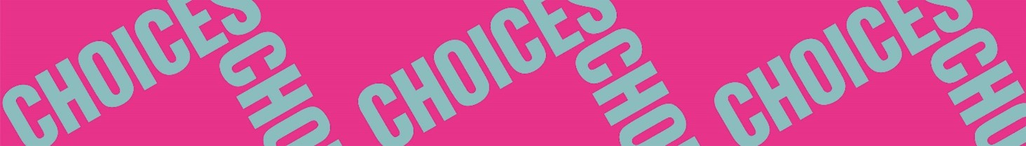

Twisted Stories
Pre-reading
Pre-reading 2: Literary terms
Place the following literary terms under the correct heading.
act – audience – author – character – chapter – climax – composition – flashback – interpretation – message – metaphor – mood – narrator – playwright – plot – plot twist – poet – point of view – quotation – rhyme – rhythm – scene – setting – stanza – suspense – symbol – theme – turning point

Short story/Novel | Poetry | Play

