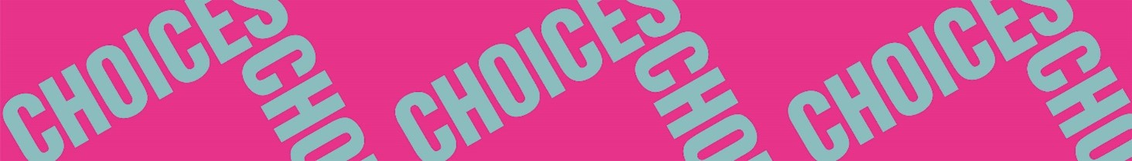

Twisted Stories
Pre-reading
Pre-reading 5: Explaining literary terms and genres
In pairs: Take turns explaining the terms below but without mentioning the specific word. You must keep talking until the word has been guessed.
fiction | non-fiction | genre
ghost story | fairytale | biography
graphic novel | horror | detective story
science fiction | newspaper article | suspense
theme | message | setting
character | plot | fantasy
climax | interpretation | point of view
symbol | foreshadowing | plot twist
narrator | unreliable narrator | first person narrator

