Leonora Carrington: The Debutante

While-reading
- A. In groups: Fill in the boxes in the graphic illustration below. Write down who the characters are and six keywords in each box to describe what happens. Also include a drawing in one of the boxes. Present your illustration to another group.

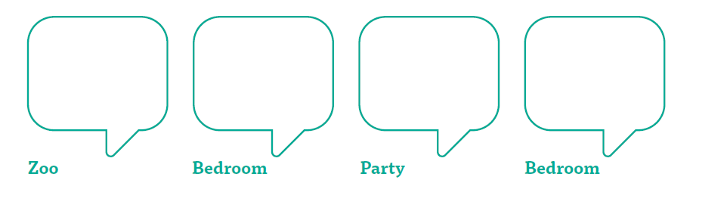

5. a. Half the class watch the programme “Leonora Carrington – Britain’s Lost Surrealist” by Tate https://www.youtube.com/watch?v=lqXePrSE1R0 and the other half the programme “Leonora Carrington” by IMAGIAmx https://www.youtube.com/watch?v=nBa5Uy9Yl0I

