Intertextuality
Intertextuality is the relationship between texts, especially literary ones. In some ways texts can be seen as speaking to each other in parts of a story. A character, an object or a symbol may appear in different story than the one you met it in first. If, for instance, you read a text in which an apple appears, this may lead you to think of:
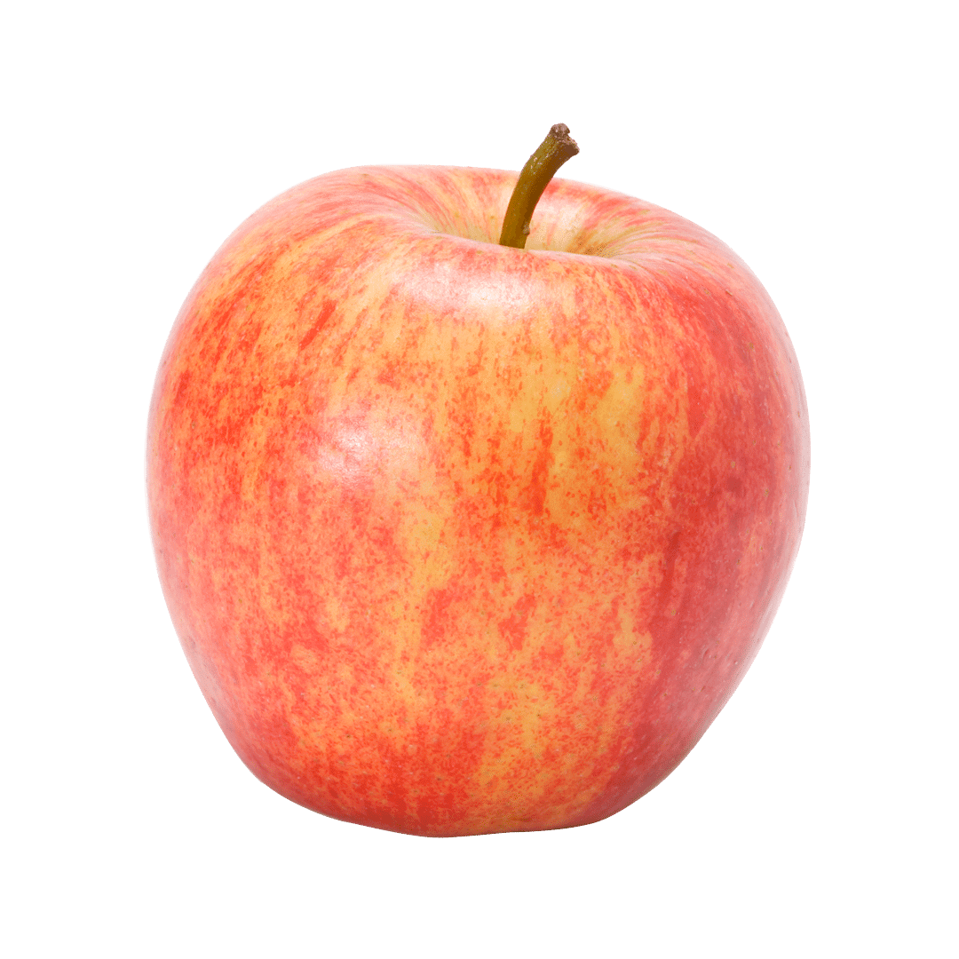 | - Personal experiences with apples, favourite apples, etc.  - The apple which – according to legend – led Newton to work out the law of gravity  - A multinational company producing electronic equipment  - The tree of knowledge in the Bible from which, according to the story, Eve tempted Adam to eat which led to their expulsion from the Garden of Eden  - A Swiss story about Wilhelm Tell who is said to have shot an apple on the top of his son’s head into two halves  - Other stories you may think of

Of these examples, the first has the least to do with intertextuality, but may give all sorts of other dimensions to your reading. Intertextuality or the references from one text to another are intended to influence the reader and add layers of depth to a text, based on the readers' prior knowledge and understanding, thus giving the story a broader perspective. In Engage! intertextuality is particularly important in the stories “How th’Irth Wint Rong”, which may be said to relate to different parts of the Bible, and “After Caravaggio’s Sacrifice of Isaac”, which refers to the Old Testament story of Abraham who is told by God to sacrifice his son. There are also references to this story in the Quaran.
Stories it may be useful to know – and themes these stories may reflect. | Mention some great stories you can think of which are often seen reflected in books and films – and the themes these stories may reflect.
The story of Cain and Abel in Genesis, Old Testament: brotherhood, fratricide, sin, jealousy

The story of Samson and Delilah in The Book of Judges, Old Testament: deceit, power, pride

The Flood (the Deluge) and Noah’s Ark Genesis, Old Testament: punishment, rebirth, salvation, new beginnings

The Virgin Mary and the Birth of Christ, New Testament: immaculate conception, motherhood, purity

The Crucifixion and Resurrection of Christ, New Testament: faith, redemption, suffering

The Betrayal of Judas, New Testament: deceit, guilt, desire

Stories about Ulysses in the Iliad and the Odyssey: courage, travelling, intelligence, inventiveness

Oedipus – a mythological Greek king who inadvertently killed his father and married his mother:truth,patricide,Oedipus complex

Sisyphus – a mythological Greek king whose punishment for cheating death twice was to continually roll a boulder up a mountain only for it to roll down again when it had nearly reached the top: absurdity.futility, labouriousness

Prometheus – a mythological Greek god who stole the fire from the gods and gave it to man. As a punishment for this, an eagle would come every day to eat his liver which then grew again over night: human striving,the search for scientific knowledge

Narcissus – a mythological Greek handsome figure who is so attracted by his own reflection in a lake that he is drowned: vanity, egocentricity/ egotism, lack of empathy

