4.22 Metaforteori

Task 1
Look at the metaphors below. Choose two that you find to be good metaphors. Discuss your choice of metaphors with a partner. What do you like about them? Why do you think they are good metaphors?

Love is a rose.
Love is a pink Fanta Exotic.
Love is a roller coaster.
Love is a schoolbag.
Love is a comfortable pillow.
Love is a car.
Love is a magic trick.
Love is a pool.

Task 2
Create your own metaphors by finishing these three sentences with a noun or a noun phrase.
Life is …
Time is …
School is …

Task 3
Watch the video “The art of the metaphor – Jane Hirshfield” from TEDed. Find it on YouTube.
Think about what the purpose of metaphors is.

The analysis of metaphors in brief – part 1
One way of describing a metaphor is by saying that it consists of two elements: tenor and vehicle.
The term tenor is what we are talking about, and the vehicle is the metaphorical way we talk about it. Maybe you can remember this by thinking about the vehicle as something that transports meaning into the tenor.
You are my star.

tenor vehicle

In the sentence “You are my star”, “You” is the what (the tenor), and “star” the metaphorical way of talking about “you” (the vehicle).

This leads us to think about what meaning we apply to a star that may be transferred to “you”. This meaning is called the ground.
In the case of “you are a star”, a star may represent light that shows the way, or something that lights up the darkness, or something beautiful, or something out of reach, and thus, these qualities may be applied (the ground) to “you”.

You are my star

tenor = vechicle

ground
(light, beauty, out of reach…)

A good metaphor makes a clear connection (ground) between tenor and vehicle and offers a (new) perspective on the tenor.
A metaphor with an illogical connection between tenor and vehicle may be less successful because the ground may not make sense to us.

Task 4
Take turns presenting a sentence from Task 1 and Task 2 to the rest of the class and analyse the tenor, vehicle and ground in the metaphors. Discuss which ones are good metaphors, and which ones seem too arbitrary. You may use the form below for your analysis.
EXAMPLE | TENOR | VEHICLE | GROUND

The analysis of metaphors in brief – part 2
A metaphor may be explicit (like the ones in Task 1 and the ones you made in Task 2). This means that tenor and vehicle are explicitly compared to each other through the verb “to be” (“you are a star”).
However, other metaphors may be implicit. These don’t directly state what the tenor is compared to, but only hint at this through the context. An example of this may be Martin Luther King’s famous phrase “Let freedom ring”. We know this is a metaphor, because freedom cannot literally ring. In order to understand the metaphor, we have to decide on the vehicle ourselves: What might ring? A telephone? Eardrums? A doorbell? Church bells? To interpret this, we need to look at the context again: What makes sense, and what interpretation does that create?

Task 5
Find explicit and implicit metaphors in the following excerpt from Martin Luther King’s speech “I have a dream” (1963):
”But one hundred years later, the Negro still is not free. One hundred years later, the life of the Negro is still sadly crippled by the manacles of segregation and the chains of discrimination. One hundred years later, the Negro lives on a lonely island of poverty in the midst of a vast ocean of material prosperity. One hundred years later, the Negro is still languished in the corners of American society and finds himself an exile in his own land. And so we've come here today to dramatize a shameful condition.
In a sense we've come to our nation's capital to cash a check. When the architects of our republic wrote the magnificent words of the Constitution and the Declaration of Independence, they were signing a promissory note to which every American was to fall heir. This note was a promise that all men, yes, black men as well as white men, would be guaranteed the "unalienable Rights" of "Life, Liberty and the pursuit of Happiness." It is obvious today that America has defaulted on this promissory note, insofar as her citizens of color are concerned. Instead of honoring this sacred obligation, America has given the Negro people a bad check, a check which has come back marked "insufficient funds.”

The analysis of metaphors in brief – part 3
One way of using this analytical approach to metaphors is to study the semantic field(s) of vehicles used in a text. These semantic fields point to perspective on the tenor(s) that the author wishes to convey, and it that way help establish the main ideas or themes of the text.

Task 6
Look at the excerpt from Martin Luther King’s speech again (Task 5). Divide the vehicles into semantic fields. Which semantic fields do the metaphors establish? What image of the lives and situation of Black people do we get through these semantic fields?

Figurative language
There are other examples of figurative language apart from the metaphor.
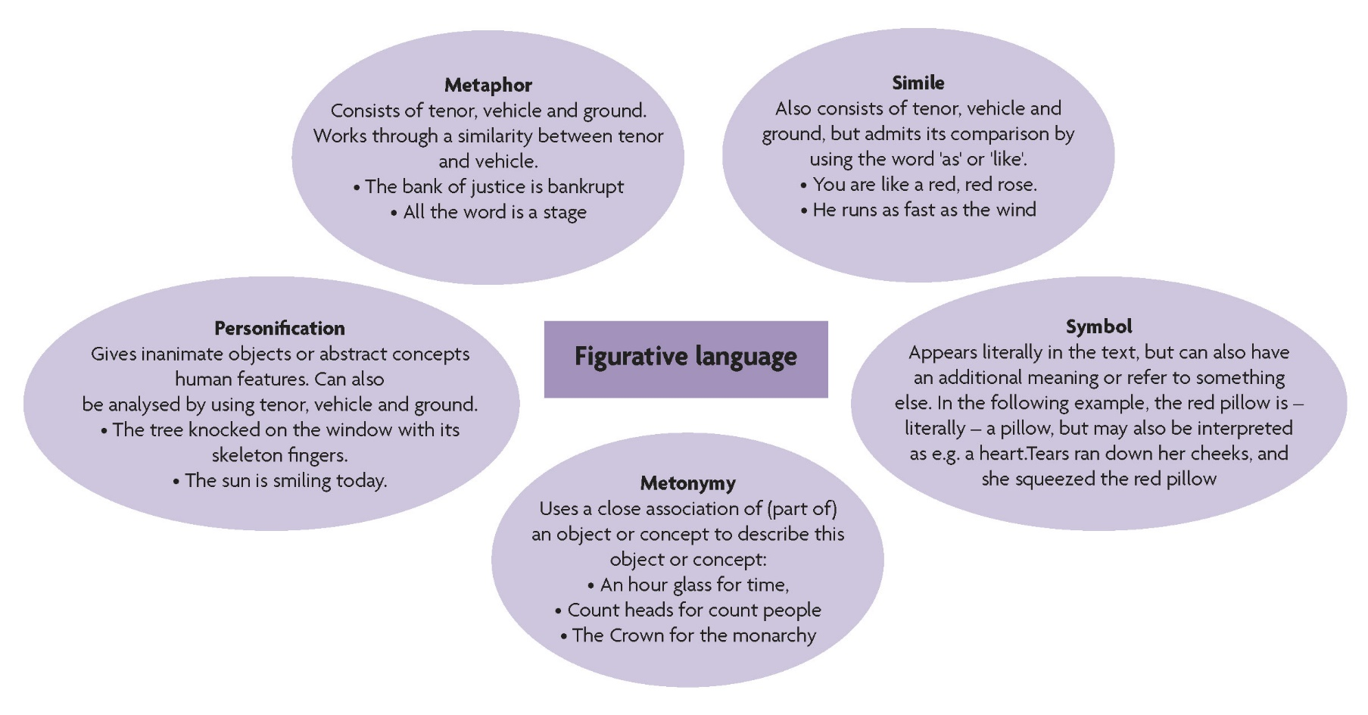

Task 7
Create your own examples for each of the five types of figurative language mentioned above.
Present your examples to a partner and see if your partner can guess which type each of our examples illustrates.

The definitions and explanations in this handout are inspired by Furniss & Bath: Reading Poetry: An Introduction. Prentice Hall/Harvester Wheatsheaf, 1996.

