How to analyse a podcast
CAPTURING THE LISTENERS’ ATTENTION IN THE BATTERSEA POLTERGEIST, p. 35
Danny Robins’ scripted introduction in ep. 1 of The Battersea Poltergeist (3:43-4:56 minutes) has been deliberately written and performed to make it sound exciting and to establish lots of foreshadowing.
- Listen to the voice-over carefully a couple of times while you fill out the worksheet below with examples of how he captures the listeners’ attention.
- Afterwards, share your findings in class, and discuss Danny Robins’ trustworthiness as a narrator. In your opinion, what seems to be the primary purpose of this podcast series – to tell a scary ghost story, or to document real-life events?

Words and expressions
Pauses
Addressing the audience

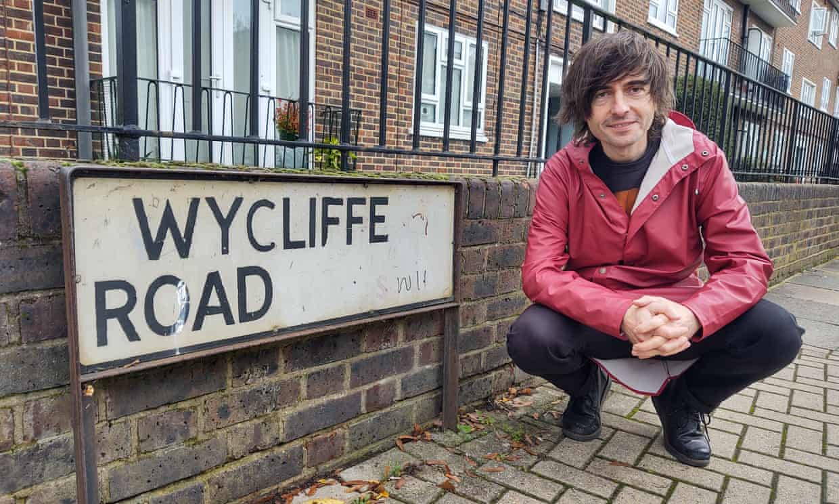
The mix of scripted and unscripted voiceovers from host, Danny Robins, makes The Battersea Poltergeist an exciting supernatural true-crime podcast. The scripted lines generate foreshadowing like a horror film. The unscripted lines, like the live recordings on location at Wycliffe Road, make it sound authentic and trustworthy.

