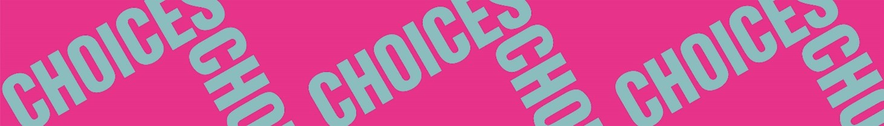

**Strangers in a Strange Land**

**Things We Carry on the Sea**

**Comprehension 2: Concrete and abstract words**

The poem is a list with things immigrants carry on their journey. Some of the things are concrete and some of them are abstract. A diploma is, for instance, a concrete word, something you can carry physically, whereas a story is an abstract word, something that can only be carried mentally.

Make two lists with all the concrete and abstract words in the poem.

|  |  |
| --- | --- |
| **Concrete words** | **Abstract words** |
| *Diploma* | *Story* |